**Companioning the Bereaved: In the room with a Bereavement Support Group**

Rabbi Judith Beiner Community Chaplain JF&CS Atlanta

[Chaplain@jfcsatl.org](mailto:Chaplain@jfcsatl.org)

**Opening ritual or reading**:

Candle lighting

Healing After Loss: Daily Meditations for Working Through Grief by Martha Whitmore Hickman

**Check - in**

**Group Content**

About Grief: Jars, Iceberg

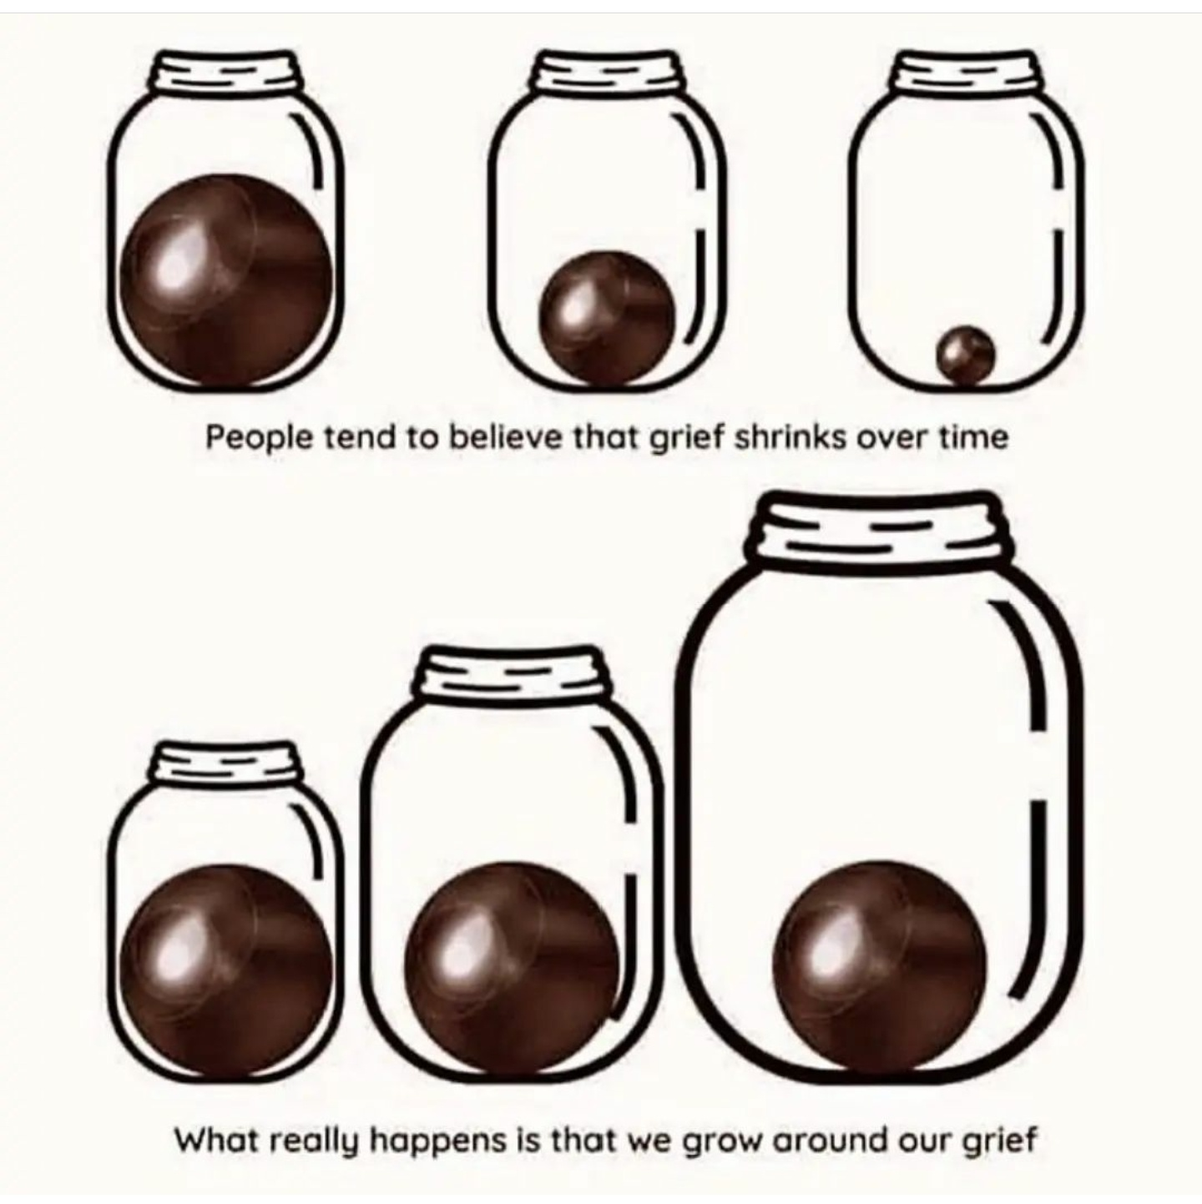

Responses to the things people say.

Issues specific to widows practicalities of living alone (eating, home upkeep etc),

Other topics grief activators including holidays, anniversaries, birthdays; death stories/trauma,

When birthdays, songs, other things can spark grief long after a loved one’s death - The Washington Post.pdf

What do I do with all of their stuff?

Rituals: Religious and Secular <https://www.theatlantic.com/health/archive/2014/03/in-grief-try-personal-rituals/284397/>

Assignments/Homework – photos, playlist/songs [Songs of Remembrance : NPR](https://www.npr.org/series/971390698/songs-of-remembrance)

**Group closing – Poetry**

**Blessing for the Brokenhearted**  
  
*There is no remedy for love but to love more*. – Henry David Thoreau  
  
Let us agree  
for now  
that we will not say  
the breaking  
makes us stronger  
or that it is better  
to have this pain  
than to have done  
without this love.  
  
Let us promise  
we will not  
tell ourselves  
time will heal  
the wound,  
when every day  
our waking  
opens it anew.  
  
Perhaps for now  
it can be enough  
to simply marvel  
at the mystery  
of how a heart  
so broken  
can go on beating,  
as if it were made  
for precisely this—  
  
as if it knows  
the only cure for love  
is more of it,  
  
as if it sees  
the heart’s sole remedy  
for breaking  
is to love still,  
  
as if it trusts  
that its own  
persistent pulse  
is the rhythm  
of a blessing  
we cannot  
begin to fathom  
but will save us  
nonetheless.

Epitaph - By Merrit Malloy

When I die

Give what’s left of me away

To children

And old men that wait to die.

And if you need to cry,

Cry for your brother

Walking the street beside you.

And when you need me,

Put your arms

Around anyone

And give them

What you need to give to me.

I want to leave you something,

Something better

Than words

Or sounds.

Look for me

In the people I’ve known

Or loved,

And if you cannot give me away,

At least let me live on in your eyes

And not your mind.

You can love me most

By letting

Hands touch hands,

By letting bodies touch bodies,

And by letting go

Of children

That need to be free.

Love doesn’t die,

People do.

So, when all that’s left of me

Is love,

Give me away.

Questions to consider:

1.  how do we help people befriend the pain of their loss (or surrender to it)  how do we guide them that dwelling in the pain is a path to healing

2.  what about someone in a group who almost entirely focuses on providing support to others?  why do they do that?  what can you do to get them to receive rather than just give

3.  the patient suffers from identity diffusion.  how do you help them create a different identity?

4.  what tools do you want someone to walk away with at the end of a group

|  |  |  |  |  |
| --- | --- | --- | --- | --- |
| unknown.gif | **Rabbi Judith R. Beiner** Community Chaplain Jewish Family & Career Services of Atlanta [chaplain@jfcsatl.org](mailto:chaplain@jfcsatl.org) | [JFCSatl.org](http://jfcsatl.org/) office: 770.677.9352 | mobile: 404.247.1110 4549 Chamblee Dunwoody Road | Atlanta, GA 30338 | | | |
| 1__#$!@%!#__unknown.gif | unknown.png | 1__#$!@%!#__unknown.png | 2__#$!@%!#__unknown.png | unknown.jpg |
| Recipient of a 4-star rating for accountability and transparency from [Charity Navigator](https://www.jfcsatl.org/blog/jf-cs-your-tools-for-living/item/jf-cs-earns-4-star-rating-for-transparency-and) .  *JF&CS is a proud partner of the Jewish Federation of Greater Atlanta and United Way of Greater Atlanta. Accredited by the Commission on Accreditation of Rehabilitation Facilities.* | | | | |